Software Development Lifecycle (SDLC) Analysis of

Paytm

Ashmith D Suvarna (NNM23IS024)

Nitte Mahalinga Adyantaya Memorial Institute of Technology

([adsashmithdsuvarna@gmail.com,nnm23is024@nmamit.in](mailto:adsashmithdsuvarna@gmail.com,nnm23is024@nmamit.in))

**Abstract**

Software development is an evolving discipline and a structured approaches becomes inevitable for application of it in building scalable, secure and efficient systems. This report aims to discuss the suitability of the models of the Software Development Life Cycle (SDLC) for Paytm, one of the leading fintech companies in India. This thesis compares how SDLC methodologies work, an overview of the requirements engineering, and discusses challenges and tactics faced in requirements validation as well as deploying of software at Paytm. Study is aiming to give insights about appropriate SDLC model for the large scale fintech platforms, and they are focused on waterfall, incremental development and spiral model.

**Contents**

**1 Introduction 2**

**2 Overview of Paytm 2**

2.1 System Overview 2

2.2 Technologies Used 2

**3 Comparative Analysis of SDLC Models 3**

3.1 Waterfall Model 3

3.2 Incremental Development Model 4

3.3 Spiral Model 6

**4 Requirements Engineering for Paytm 8**

4.1 Functional Requirements 8

4.2 Non-Functional Requirements 8

4.3 Requirements Validation Strategy 8

4.4 Challenges in Requirements Validation 8

**5 Conclusion 8**

**6 References 9**

**1. Introduction**

Paytm is a one of India biggest digital payment company that provides services such as mobile recharges, bills payment, wallet services, e-commerce etc. To compile millions of transactions daily, the platform makes use of a solid cloud based infrastructure. Paytm being a large scale software is needed an efficient software development lifecycle (SDLC) to constantly update, add new features and to be stable. This paper is a comparative study between Incremental and developmental model, spiral model and waterfall model in terms of Paytm’s software development. In addition it explains the requirements engineering and their challenges.

**2. Overview of Paytm**

**2.1 System Overview**

Paytm offers an integrated digital payment ecosystem that allows users to perform transactions, pay their bills as well as shop online. The system allows multiple devices, personalized user experience and real time processing while secure transaction across the devices. Paytm is an Indian fintech platforms that provides services like mobile wallets, UPI Payment, E commerce. The platform is available across, India and it is multilingual.

**2.2 Technologies Used**

**Technologies Used**

* AWS (Amazon Web Services) is used as Cloud Platform.
* Architecture: Microservices-based
* Database: NoSQL (DynamoDB, Cassandra), MySQL
* Payment Gateway: Paytm Payment Gateway, UPI integration
* Programming Languages: Java, Python, Node.js
* DevOps: Continuous Integration & Continuous Deployment (CI/CD)

As a platform being powered by many different layers of tech stacks, Paytm uses the unique combinations of disparate tech stacks (eCommerce, mobile app, backend, etc) to enable seamless transaction experience for its customers. All of these technologies are big enough, but Paytm has used different other tools and frameworks to improve services.

**3. Comparative Analysis of SDLC Models**

**3.1 Waterfall Model**

1. **Requirements Definition** : In this phase, all system requirements are defined at one shot. The user authentication, payment processing, wallet management and bill payment functionalities are included in this. At this stage, exhaustive documentation is required for changes to be implemented later on because changes are difficult to implement.
2. **System & Software Design :** All of this is developed into a complete architecture, with database structures, API endpoints with proper swagger documentation and server infrastructure on AWS. Before start, develop is mapped out from every part of the system to any detail.
3. **Implementation :** The previously we used architecture is implemented, and also developers start to code the entire system at once. The requirements are not changed, development follows the linear path.
4. **Integration and System Testing** : Integration and particularly a lot of extreme testing of the entire system comes after development is done. Functional testing, performance testing and security testing are included.
5. **Operation and Maintenance :** The fully developed platform is deployed in production. During the maintenance phase, the bugs and issues are addressed that may have been found after launch. It also takes very long time to bring updates because of the very rigid nature of Waterfall Model.

**Suitability for Paytm:**

**Pros:**

* Well-documented and structured approach.
* Suitable for smaller, well-defined projects with minimal expected changes.

**Cons:**

* Not very flexible to adapt with the change of the user’s needs very quickly.
* It’s not suitable for rapid iteration since long development cycles.

**Conclusion:** For Paytm, this is not a verdict that would be suited for this, since it is often an on-going process that requires frequent updates, rapid delivery of new features, and flexibility to respond to different user preferences.

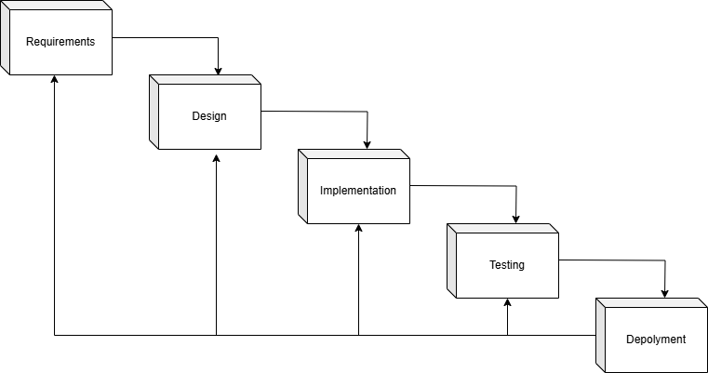

**3.2 Incremental Development Model**

1. **Planning and Initial Requirements** : They feel the list of high priority features — i.e. user authentication, payment processing, and wallet management — are important to develop. The first iteration requirements are finalized leaving room for future updates.
2. **Feature-wise Development** : Paytm’s policy is to release the entire system all at once, instead, it continues releasing new features. For instance, it improves payment processing; it can introduce new payment methods and improve managing my wallet. The cycles are split — a separate cycle in which design, development, testing, deployment, occur for each feature.
3. **Continuous User Feedback :** Beta users use the app and feedback to usage patterns and explicit ratings, and we deploy each increment. This feedback is analysed, the adjustments are made and the next increment is launched.
4. **System Testing and Refinement :** All the new features or updates get tested extensively with regard for their performance, bug fixes and security checks. There are automated pipelines for continuous integration, continuous testing.
5. **Deployment and Monitoring :** Batches of features are released to production, and little downtime comes with it. Sometimes to test different versions of a feature on the A/B testing before deploying the feature.
6. **Iteration and Maintenance :** The developers work with all the existing features, resolving the user reported issues and implementing the features as per the changes in the user needs.

**Suitability for Paytm:**

**Pros:**

* Incremental releases releasing of new features at a faster time to market.
* Fast changing to the needs of the user.
* This is because it is continuous testing and it provides the reliability and performance.
* Supports cloud based micro services network architecture and easily scalable.

**Cons:**

* In particular, the needs of the system to avoid conflicts are such that effective integration strategies must be employed.
* It needs strong version control mechanisms to be managed with number of development branches.

**Conclusion:** Very fit indeed, since the updates are likely to continue, and the enhancements are going to be customer-driven.

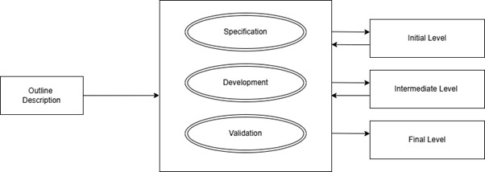

**3.2 Spiral Model**

1. **Risk Analysis and Prototyping :** Before development of such feature as UPI integration or AI based fraud detection is launched at a large scale, Paytm works out all the risks associated with it. They develop small-scale prototypes before moving on to the large scale development.
2. **Concept Validation and Refinement :** Once the prototype goes through and the feature is tested, Paytm would refine the design of the feature with the help of the data from it. The process of iterating and ensure that the feature passes the technical limitations and business objectives.
3. **Development and Testing :** Various cycles of building and testing the features are used. Developers will change their stuff depending on the risks they are trying to avoid and early feedback from beta users.
4. **Validation and Security Testing :** Both the features are rigorously security tested for the compliance of regulatory standards and to protect the user data.
5. **Gradual deployment :** A small group of users is targeted first by the developed feature. The deployment is scaled to a larger audience once real world performance is monitored and changes are made.
6. **Refinement and Continuous Improvement :** The developed feature targets firstly a small group of users. After real world performance is observed and changed, the deployment is scaled to a larger audience.

**Suitability for Paytm:**

**Pros:**

* Robust system development is based on strong risk management.
* Refining features such as fraud detection under AI are improved using iterative improvements.
* Suitable for high-risk functionalities such as security upgrades and payment processing.

**Cons:**

* Expensive and time-consuming for simple features.
* The assessment of risks is very much a very skilled team affair.

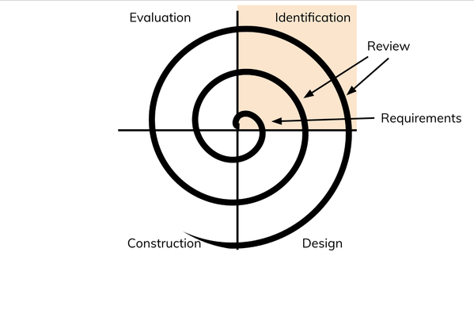**Conclusion:** This is suitable for high risk features such as security updates or AI based fraud detection but may not be needed for everyday/maintenance types of feature development.

**4. Requirements Engineering for Paytm**

**4.1 Functional Requirements**

* **Account Management:** Register & login with user with OAuth. Multi-factor support (MFA) and social media sign in.
* **Payment Processing:** Real-time payment processing with support for UPI, credit/debit cards, and wallets.
* Users can add, withdraw funds and transfer funds. Integration with banks and UPI.
* Mobile Recharge, DTH Recharge and Utility Bill Payment.
* **AI for Fraud Detection:** AI based fraud detection in order to secure unauthorized activities.
* Collection of user engagement data for personalization and marketing strategies is termed as User Analytics & Insights.

**4.2 Non - Functional Requirements**

* **Performance:** The system must meet current and future load requirements without reducing performance from the service end user.
* **Availability:** High uptime through multi-region AWS deployment and redundant servers.
* End-to-end encryption, secure user authentication mechanisms, periodic security testing among others, are some of the things which will add to security.
* **Performance:** Low latency for transactions and quick processing times.
* **Compliance & Legal Considerations:** Adherence to RBI regulations, GDPR, and PCI-DSS standards.

**4.3 Requirements Validation Strategy**

* Stakeholder Reviews: Collaborating with business teams, developers, and end-users to refine requirements.
* Prototyping & A/B Testing: An early test of a UI/UX before implementing, and using data driven decisions on user behaviour.
* Integration of unit, functional and regression testing to satisfy numerous regulations, in the Automated Testing & CI/CD Pipelines.
* Vulnerabilities: Continuously assess them and conduct tests of penetration.
* User Feedback Loops: Data on what is going in real time allowing us adjust to unknown needs of our customers.

**4.4 Challenges in Requirements Validation**

* **Fintech user need:** Rapid changing user expectations in the fintech industry.
* **Global Compliance Issues**: Adapting to different regional financial regulations.
* When to Handle Peak Traffic Loads during Festival and Sales Events are Scalability & Performance Bottlenecks.
* **AI Bias in Fraud Detection:** Ensuring fairness and accuracy in AI-based fraud detection systems.
* Continuous threat of payments and data security.

**5. Conclusion**

The Waterfall Model with its linear and structured approach doesn’t fit Paytm’s needs as it is very rigid and cannot adapt to user needs changing in a fast pace nor in market trends. Being in a very dynamic environment where the regulations, technology, user’s expectations keep changing fast, Paytm operates. Since it is difficult to manage, the Waterfall Model is not efficient for platforms handling constant updates, and deploying features quickly.

Alternately, Incremental Development Model is the perfect fit with Paytm’s requirements. Because Paytm can start shipping out core features early on and then continuously enhance the features, the development process is broken down into smaller, easily manageable increments. With this approach, Paytm is moving faster to the market and stays ahead of the competitors. Furthermore, the Incremental Model’s iterative nature ensures that we can continue to get user feedback throughout the iteration.

An alternative that is great for Paytm, in the case of features such as high risk, like security upgrades, AI based fraud detection, or regulative compliance, is the Spiral Model. Risk analysis and development through iterations are core to the Spiral Model, thus issues are spotted early during the development process.

So in conclusion, the reason behind Paytm becoming what it is is its ability to switch according to the users need, take care risks and provide better quality features as quickly as possible. Incremental Development Model has better rapid feature deployment and scalability features, Spiral model is more suitable for high risk functional implementation. Combining these models’ strengths into one robust, secure, and user friendly platform while meeting the huge demands of millions of users in India can become a reality with Paytm. Paytm’s decision of the SDLC model is a strategic decision and not a technical one as it directly affects its ability to innovate and keep up with the competition in the fintech industry.

**6.References**

1. Sommerville, I. (2015). Software Engineering (10th Edition).
2. Paytm Blog - <https://blog.paytm.com/>
3. Wikipedia - Paytm; as edited on 3rd February 2025 - <https://en.wikipedia.org/wiki/Paytm>
4. AWS Whitepapers on Paytm's cloud infrastructure.